|  |
| --- |
| The Rapid Extraction of Suspicious Traffic from Passive DNS |
| Wenbo Wang1, Tianning Zang1 and Yuqing Lan2 |
| 1 Software Institute, Beihang University, Huayuan Lu Street, Beijing, China  *2* Software Institute*,* Beihang University*, Beijing, China*  {Wenbo Wang, Tianning Zang}@si.beihang.edu, lanyuqing@buaa.edu.cn |

Keywords: DNS, Amplification attack, Random Subdomain Attack, Domain generation algorithm, Malicious domain name.

Abstract: The network traffic is filled with numerous malicious requests, most of which is generated by amplified attacks, random subdomain name attacks and botnets. Through using DNS traffic for malicious behavior analysis, we often need to test each domain alone. Besides, the amount of data is very large, simple filtering cannot quickly reduce the need to detect the number of domain names. As a result, it takes a lot of time to calculate on the premise of limited resources. Therefore, this paper introduces a extraction scheme for DNS traffic. We designed a simple and efficient method for extracting three kinds of attack traffic with the largest proportion of traffic. Besides, the method of statistics and classification was used to deal with all the traffic. We implemented a prototype system and evaluated it on real-world DNS traffic. In the meanwhile, as the recall rate reached almost 100%, the number of secondary domain names to be detected was reduced to 8% of the original quantity, and the DNS record to be detected was reduced to 1% of the original number.

# 1 INTRODUCTION

As a logical address to define a device in the network location, IP address is provided by the IP protocol digital unified address identification,. With the gradual increase in network equipment, memory difficulties of IP address emerged. In 1983, Paul Mockapetris proposed the architecture of DNS and proposed to improve it into a distributed and dynamic database domain name system, which refers to the prototype of the domain name system used today. Domain name as a tool to bring us convenience at the same time, but also to the network of malicious acts provided a convenience.

For these malicious behavior, there are blacklists and the corresponding reputation systems such as DGArchive (Plohmann et al., 2016), Notos (Antonakakis et al., 2010), DSBL (Serdar Argic, 2009). There are some detection systems like Pleiades (Antona-kakis et al, 2012), EXPOSURE (Bilge et al, 2011), FluxBuster (Perdisci et al, 2012). Besides, there are some systems using depth learning model to solve the problem like LSTM (Woodbridge and Anderson, 2016), word2vec (Goldberg and Levy, 2014). When dealing with passive DNS data from Shangxi and Guangdong Telecom, the amount of data is too large to easily complete processing of all data. If only the white list is used to filter data, it leads to ignoring attacks by benign domains or attacks against benign domains. We hope to build an efficient model for malicious traffic extraction by simplifying or referring to these detection methods.

In this paper, we propose a malicious traffic location model. Using some statistical characteristics and pre-trained model, we can quickly locate suspicious malicious traffic. This model is deployed in the local server or recursive network edge node, and monitor DNS request and response of the network, which can analyze the data at regular intervals, and quickly locate the traffic containing malicious domain names for further analysis and detection. According to the report (Orthbandt, 2015), in the malicious traffic statistics, random subdomain names accounted for 80%, amplification attacks accounted for 15% and C&C traffic occupied 5%. Besides, our model will also address these areas. Our model to locate malicious traffic from massive data has a high recall rate. At the same time, it can greatly reduce the detection of malicious domain time spending,. Because many interferences are removed, the effect of detection is greatly improved. The experiments are carried out at different time in Shanxi and Guangdong provinces, proving that the model has good adaptability.

This paper makes the following contributions:

* we propose a lightweight model for malicious traffic extraction, which can effectively locate malicious traffic in large-scale ISP (Internet Service Provider) networks and rapidly reduce the magnitude of further traffic detection;
* we provide the prototype implementation of the model, and experiment in the network environment of different periods in the two provinces. The result has excellent recall rate, reduced traffic scale, and also has high applicability;

The remainder of the paper is organized as follows. Section 2 introduces some background on DNS and related works. We provide an overview of our system in Section 3. Each part process is described in Section 4. The experimental results are presented in Section 5 and we discuss the limitations of our systems in Section 6. Section 7is the conclusion of the paper in.

# 2 Background and Related Work

**2.1 DNS Amplification Attack**

DNS amplification attack uses the DNS server as a springboard to amplify traffic. In the case of a normal DNS query, the source IP address sends a DNS query to the DNS server, and the source IP address is returned. In addition, the attacker will attack the target IP address forged as the source IP address and the query results will return to the forged IP address. Usually, a DNS query packet size is about 60 bytes. If you initiate a DNS query with a request type of ANY, it indicates a request for all DNS resource records (including A record, MX record, CNAME record, PTR record, etc.). Then, the returned packets typically reach hundreds of bytes to thousands of bytes. Akamai researchers found a DNS amplification attack using TXT records in 2014 (Kovacs, 2014). An attacker uses a tool named DNS Flooder to obtain a TXT record by querying guessinfosys.com with an attack peak of 4.3Gbps.

Tama et al used the method of anomaly detection to model the network data stream according to the header attribute, and adopted the naive Bayesian algorithm to score each incoming data stream to evaluate the rationality of the message (Tama and Rhee, 2015). Karnwal et al transformed the one-dimensional timing into multidimensional AR model parameters through dimension transformation, and used the support vector machine algorithm to study and classify the data stream (Karnwal et al., 2013). Wang et al have considered the use of anomaly detection methods, who also use hidden Markov model to describe the change of data header in data stream (Wang et al., 2015).

**2.2 Random Subdomain Attack**

Domains generated by random subdomain attack (also known as Random subdomain DDoS or the Random QNAME attack or the Nonsense Name attack) (Liu, 2015) having the same SLD (second-level domain name) or third-level domain name have numerous different random subdomain names, and these SLD is usually legal. This attack is a DDoS attack against the domain name server, or even against the root domain name server (VeriSign, 2015).

An attacker uses infected network devices to construct DNS queries for a random subdomain based on a legal SLD. These queries first arrive at the recursive DNS server. Since the server does not have the corresponding cache, these queries are propagated to the top-level domain name server and the domain authoritative server. These processes consume query resources rather than bandwidth, yet will obviously slow down or even prevent the domain name of the normal query and cause over-loading of the server (Rizzo et al., 2016).

There is no sophisticated and mature real-time detection method for random subdomain attacks yet. For example, the solution given by secure64 is to increase memory, increase recursive complexity, and automatically block IP with too many failed requests (Andrew, 2015).

**2.3 Botnet Based on DGA**

DGA (Domain generation algorithms) uses algorithms to pseudo-randomly generate domain names. These domain names are used to establish the connection between the infected host and the C&C servers (command and control servers). The traditional botnet uses a fixed IP or domain name to establish a connection with the C&C servers, which is poorly concealed and easily found.Afterwards, there are P2P-based botnets such as Nugache (Stover et al., 2007), Storm (Wikipedia, 2010), Waledac (Williams, 2010), Zeus (abuse.ch, 2011), etc. with good robustness and stability but also high difficulty of implementation and maintenance costs. At present, most of the active botnets use DGA, relying on the concentration of C&C server. Compared with the first two, it is simpler while considering the advantages of stability and concealment.

The detection of DGA algorithm mainly includes black list, machine learning method and reverse engineering. L.Bilge (Bilge et al, 2011) extracted a total of 15 features from the DNS data based on time, DNS response, TTL (Time to Live), domain name characters. The J48 decision tree is used to train the classifier and make up for the inability to detect a malicious domain name that has been used only once by an IP address with the perfect feature selection. Besides, they also set up the EXPOSURE system to conduct extensive detection of malicious domain names. B. Rahbarinia proposed a behaviour based system named Segugio (Rahbarinia, 2016). Segugio efficiently discovers the newly added malware-control domain name by tracking DNS requests that are infected by host malware in a large ISP network. Notos (Antonakakis et al., 2010) and EXPOSURE establish domain-IP mapping relationship model (using the characteristics of the domain name string, the domain name carries malicious content and other information) without using the local DNS server downstream host request behaviours. Compared to these two, Segugio monitors DNS user requests for DNS requests, focusing on the precise "malware-only" domain name. J. Woodbridge (Woodbridge and Anderson, 2016) and other researchers use LSTM to predict DGA-generated domain names that can be run in real time and do not require artificially created features. D. Plohmann, F. Fkie and others have conducted a lot of detailed work on the DGA (Plohmann et al., 2016). They conducted a comprehensive study of 43 DGA malware families and variants, presented a taxonomy for DGA, and used this to classify and compare the studied DGA.

In general, the above-mentioned detection methods use the Alexa top domain name as a whitelist for initial filtering, but the number of filtered domain names is quite limited.

**2.4 Related Work**

The biggest difference between our work and the detection model for traffic refers to that we do not focus on false positives. We want to get the highest possible recall rate, extraction rate and extraction efficiency.

Regarding the work of amplification attacks, the most significant point is that we only need to use passive DNS rather than complete package. At first, we attempted using logistic regression, hoping to achieve binary classification with a small number of attributes. We try to modify the manual annotation to improve the recall rate, but even if this is done, the difference between the number of positive cases and the number of negative cases is still very large. As a result, we cannot get stable corresponding to the corresponding weight of the various features. We consider using more practical statistical methods and observation experience in the classification. Besides, we are concerned about the proportion of TXT queries and ANY queries. To save the additional text information of the domain name TXT records are used and the content is written in a certain format, like the SPF format. Additionally, this format is used to register a domain name for outgoing mail all the IP address. When an attacker uses an TXT record to amplify an attack, it uses the pre-registered domain name and sets the txt record content of the domain name as long as possible to increase the magnification. Any query will query all the records of the domain name, the attacker chooses to use ANY query, they can easily get a lot of magnification. The only concern about the proportion of TXT query and ANY query is to minimize the extraction time, in the process of doing traversal can record each domain name TXT query and ANY query number, and the number of all inquiries.

The extraction of random sub domain attack traffic has similarities with above method. We mainly focus on the number of sub domain names and domain name query success rate. In the process of extracting, the reverse domain name parsing record (suffix is *‘.in-addr.arpa’*) and some misconfigured domain names (suffix is usually *'.localhost'* or *'.local'*) are cleaned first, which will generate a large number of subdomains and unresolvable records.

For the extraction of DGA domain. Effect of only using the blacklist filtering is poor. Simple use of statistical data for fitting leads to very low extraction rates due to the diversity and complexity of the DGA species. It takes too much time to build complex models and detection methods, so we choose to use black and white list training model as well as select only the domain name character.

# 3 System description

Our system aims to extract DNS traffic from amplification attacks, random subdomain attacks and DGA. Given a continuous flow of time, or even only one hour of traffic data, we can initially determine the malicious part. Intuitively, we can divide a batch of DNS data into two parts, some of which only contain legitimate access, and the other part contains all the malicious traffic. Our data source is passive DNS data including the recursive domain name server response history information. We collected recursive DNS server data from Shanxi and Guangdong, with an average of 80 million data per hour in Shanxi and an average of one hundred and seventy million data per hour in Guangdong. During the process of extracting DGA domain name traffic, we collected a blacklist with a whitelist, where the blacklist came from the 360 netlab, the whitelist used alexa top 1 million.

**3.1 System Overview**

In this section, we conduct a high-level overview of our system. According to Figure 1, we divide the system into two parts, respectively, the Passive DNS pre-processing module and the traffic extraction module. Besides, we will describe each module function and discuss how to achieve the goal together as well as maximize the recall rate and efficiency.

The process of pre-processing mainly achieves three goals. One is to remove the DNS records containing the wrong domain name, that is, to clean data. For example, there are some illegal characters like *‘!’* and *‘_’* appeared in domain names. The second is to eliminate unrelated traffic, on the one hand will be benign traffic and malicious traffic will not appear in the traffic removed, such as traffic of reverse DNS. On the other, we will try to remove domain names that do not appear in malicious traffic during a certain type of traffic extraction process. For example, the domain name in the whitelist can be removed during the extraction of DGA traffic. The third is to calculate the eigenvalues for the traffic extraction module, such as the proportion of ANY queries for each domain name.

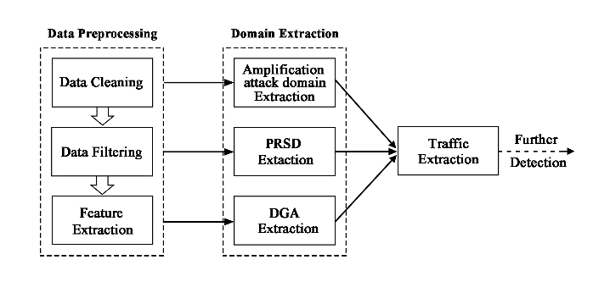

Figure 1: System Overview.

**3.2 Statistical Features**

This section will define key statistical features and introduce the calculation method. We calculate nine features for each domain name, namely, bigram, trigram, fourgram, entropy, length, Qar (query ANY record ratio), Qtr (query TXT record ratio), sdc (subdomain count), and nxdr (non-exist subdomain ratio).

**3.2.1 Definitions and Notation**

A domain name is consisted of two or more groups of ASCII or language characters, each of which is separated by *‘.’*. The rightmost part is called a TLD (top-level domain name). SLD (Second-level domain) refers to the domain name under the top-level domain name, which is registered by the domain name registrant. Third-level domain name under the SLD, can be called sub-domain name.

**3.2.2 N-gram Features**

SLDs are taken out of the domain name in the whitelist. Each of the SLDs is added with '^' at the beginning and ended with the '$'. For example, there is a domain, *‘www.buaa.edu.cn’* with SLD of *‘buaa’* and becomes *‘^buaa&’*. These SLDs are used as training corpus to measure the N-gram frequency distribution, where n = 2, 3, 4. Besides, given a domain name, we can use their SLD respectively to obtain the corresponding Bigram, Trigram, Fourgram features.

**3.2.3 Entropy Features**

Considering a domain name, we extract the SLD and calculate its entropy according to equation 1, where p(c) is the probability of occurrence of each character in the SLD. Entropy can show the randomness of a domain name.

$H\left(d\right) =-\sum{p\left(c\right)*{Log}_{2}p(c)}$ (1)

**3.2.4 Ratio-related Features**

Some ratio-related features can be calculated through the DNS record. These features are expressed by proportion rather than absolute number, such as the proportion of ANY type queries to the total number of queries.

**3.3 Data Preprocessing**

The preprocessing module performs three layers of raw data collected, respectively, data cleaning, data filtering and feature extraction.

**3.3.1 Data Cleaning**

First, all the data is to be cleaned. A valid domain name contains only 26 alphanumeric characters (including uppercase and lowercase), numbers, dashes, and points used to split each segment. It is easy to clean up these data by building regular expressions. Another part is domain names without TLD. There are many reasons for this situation, such as configuration and human reasons.

**3.3.2 Data Filtering**

Secondly, the data filtering operation is carried out. The first part is to filter the reverse domain name. Inverse address resolution refers to the mapping from IP address to domain name, which is mainly applied by mail servers to prevent spam. The return packet is small and is not suitable for use as a zoom attack. Therefore, there is no behavior in the malicious traffic that uses the reverse parsing record to attack. The second part is to filter the domain name generated by the configuration errors, which is quite common. Among them, *"local"* and *"localhost"* as the suffix domain name appears most. The third part is to filter IDNs (Internationalized Domain Names). IDNs are a general term for non-English-speaking countries to promote their own language domain name systems with punycode encoding.

**3.3.3 Feature Extraction**

Another major function of the module is to convert DNS records into corresponding feature vectors. DNS records is divided by each hour to form a DNS resource records sequence, S = {rr1, rr2, ..., rrm}, where each resource record contains the domain name, source IP, request type, return type, rcode, timestamp, and so on. Each of the SLDs under the TLD is an independent branch, which is managed by a different domain name registrant. Therefore, our statistical features are for the SLD. We count the number of queries group by each SLD within a period of time as qc, the number of queries which type is ANY as qac, the number of queries which type is TXT as qtc. We set any query ratio qar = qac / qc, txt record query ratio qtr = qtc / qc. According to rcode to determine whether the domain name can be successfully resolved, we calculate the proportion of non-existent domain name nxdr. We count the number of sub-domain names for each SLD in the time interval, named sdc. In this paper, we choose the interval as one hour, which will be discussed in Section 4.2. Then, we calculate the entropy, bigram, trigram, fourgram, length, and label whether it is in alexatop 100 million white list based on these SLD.

Eventually, we get each record for SLD, qar, qtr, nxdr, sdc, entropy, bigram, trigram, fourgram, length, and inwhite.

**3.4 The Extraction of Domain Names**

This module is to take advantage of the SLD and its features, and extract the domain name which involves malicious behaviours. The extraction process aims at three types of attacks, namely, amplification attacks, random subdomain attacks, and DGA domains.

**3.4.1 Domains of Amplification Attack**

This part is mainly to find the part of the domain that acts as a springboard in the amplification attack. The attacker uses these domains by using their TXT records or ANY queries to return all the resource records of the domain name. We use the qar and qtr obtained in section 3.3. By formula 2, we set a parameter β. When qar+qtr<=β, the result is 0. When qar+qtr>β, the sum of qar and qtr was positively correlated with S1. At the same time, we set threshold α, in which S1>α, and identified as the suspected amplification attack of traffic. Here the value of α is 0.1 and the value of β is 0.05. The threshold value will be carefully discussed in the next chapter.

$S_{1}=max⁡\{0, 1-e^{-\frac{qar+qtr-β}{β}}\}$ (2)

**3.4.2 Domains of Random Subdomain Attack**

This part aims to locate the domain name used by random subdomain attacks. The attackers generate numerous sub domains randomly under the SLD, and these domain names do not exist. Therefore, we multiply sdc with nxdr to represent the possibility of malicious use, and this value range is large. We use formula 3 to change the result to between 0 and 1. Here, we choose θ as 0.3.

(3)

$$S_{2}= \frac{e^{θ(sdc*nxdr)}-1}{e^{θ\left(sdc*nxdr\right)}+1}$$

**3.4.3 Algorithmically-Generated Domains**

ADGs (YADAV et al., 2010) means the domain name generated by the DGA algorithm. The domain name generated by DGA is second-level domain, so this part of the extration is concerned with the SLD in the traffic. Our model is trained with black and white lists, and data sources are presented in section 4.1. We extracted the SLD of each domain name in the list, and calculated their length, entropy and n-gram respectively, where n=2,3,4. We chose Random Forests as classifiers. When each tree is trained, a data set of the same size as N can be trained (bootstrap sampling) from a full training sample (sample number N). Random Forests are trained at a faster rate, which can balance errors.

We get the domain name from the previous module. For each SLD, we first remove it if it is in the white list, and then classify the remaining domains into categories in turn to obtain the suspected ADGs.

**3.5 The Extraction of Domain Names**

Further detection often requires complete DNS resource record. Therefore, after obtaining the domain name through Section 3.4, the module will restore this set of secondary domain names to the corresponding traffic, that is, the original DNS resource record. The operation is very simple, this batch of secondary domain name as a list, compared with the data after cleaning, to retain the records which have the same SLDs.

# 4 Evaluation

In this section, we report the results of the evaluation of the entire system. First, we introduce the data we use, and then discuss the parameters in section 4.2. Finally, the results of traffic extraction are demonstrated.

**4.1 Datasets**

Our data comes from CNCERT / CC including Shanxi Telecom China Passive DNS data and Guangdong Telecom Passive DNS data. The data from Shanxi Province is collected on October 15, 2015, which contains 23 hours. According to figure 3(a), the total amount of DNS records close to 2 billion. The number of domain names that are not duplicated per hour is between 100 thousand and 200 thousand. We labelled 101 DDOS related malicious domain names and 322 DGA related domain names. The data from Guangdong province is collected on April 14, 2017, which contains 9 o'clock to 16 o'clock a total of 9 hours of data. As shown in Figure 3(b), the total number of DNS records is more than 1.1 billion, and the number of distinct secondary domain names per hour is about 600,000. We labeled 163 DDOS related malicious domain names and 265 DGA related domain names.

In the extraction of DGA traffic, we use the alexatop100 million domain name list as a whitelist. Besides, we downloaded the DGA blacklist from the 360 netlab as a blacklist containing 1037304 second level domain names. Figure 4 presents the relationship between the length and the entropy of the secondary domain name from the blacklist and whitelist. When consistent in length, the domain of DGA is often associated with a greater entropy value.

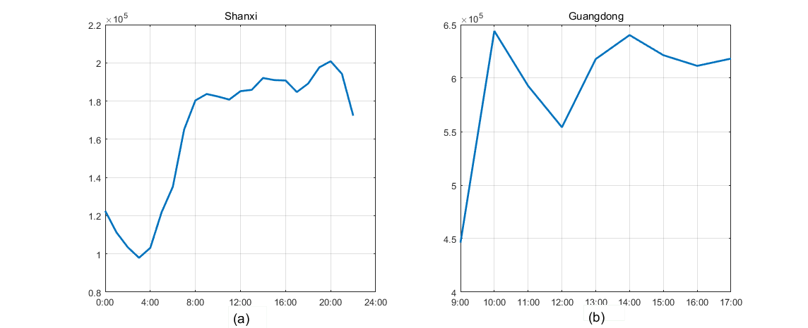

Figure 2: Number of distinct SLDs in Shanxi and Guangdong

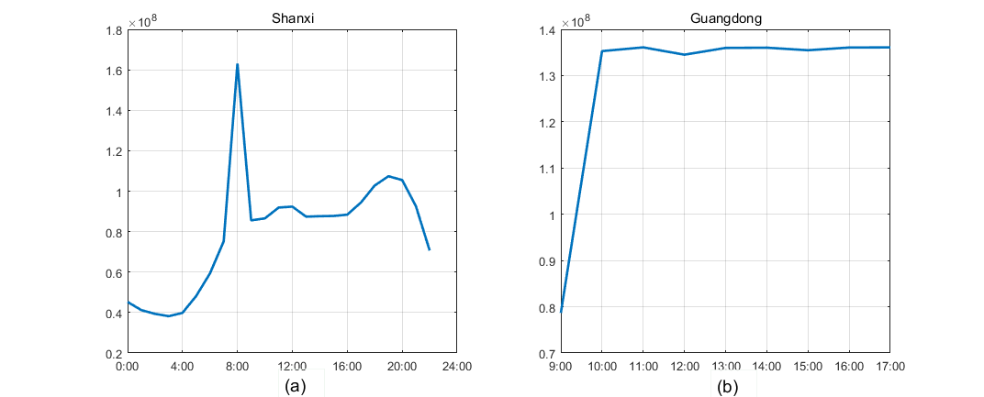

Figure 3: Number of DNS records in Shanxi and Guangdong

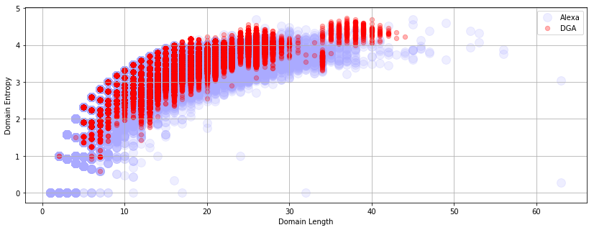

Figure 4: The entropy changes with the length of the domain name

**4.2 Parameter Analysis**

We first discuss the parameters appearing in the 3.4.1 section, where three parameters are involved, namely, the time interval and the threshold value α to judge whether the domain name is suspicious, and the parameter β in formula 2. The values of time interval are 10 minutes, 30 minutes, 60 minutes and 120 minutes, and the values of alpha are 0, 0.05, 0.1, 0.2, 0.3, 0.5 and 0.6. Besides, the values of beta are 0.07, 0.1, 0.15 and 0.2. Figure 5 shows that the Z axis represents the recall rate. When the time interval is 10 minutes, the recall rate is always above 0.98. Additionally, the maximum recall rate was 0.94 when the time interval was 120. The two cases cannot be satisfied with the values of α and β. Table 1 shows the relationship between the value of the different parameters and the number of suspicious domains. Obviously, the time interval selected as 30 minutes or 60 minutes can achieve the effect of little difference. But the number of executions of the former is twice that of the latter, so we set the time interval to 60 minutes. To obtain as few domain names as possible, we set α to 0.1 and β to 0.05.

Another parameter that needs to be discussed is θ in Equation 3 in Section 3.4.2. The smaller the value of θ, the smoother the curve of this function. As shown in Figure 6, the relation between the value of θand the number of domains extracted is described. When θwas 0.1, the recall rate was 50%. When θis greater than 0.2, the recall rate is 100%.

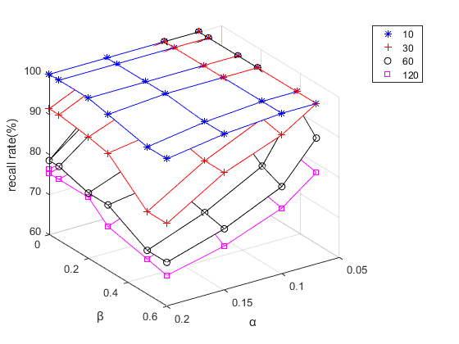

Figure 5: The effect of different α, β, and time intervals on the recall rate

Figure 6: The relation between θ and the number of domain names in domain names extraction of PRSD

We discuss our choice of features in the processing of the DGA domain name. On the one hand, we cannot select too many features to ensure that the training time and classification time of the model cannot be too long. On the other, we cannot choose too few characteristics, otherwise it is difficult to achieve satisfactory recall rate. Finally, we select the SLD’s length, entropy, and bigram, trigram, fourgram, these five characteristics. In addition, we use random forests as classifiers. As shown in Figure 7, we observe the result through confusion matrices, with a recall rate of more than 96%. Besides, we carried out tenfold cross validation, recall rates are above 85%, the highest can reach more than 98%.

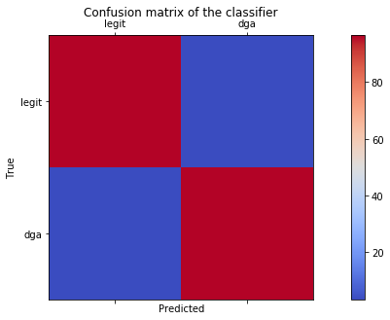

Figure 7: The effect of different α, β, and time intervals on the recall rate

Table 1: When the recall rate is 100%, the relationship between α, β and the number of suspected domain names

|  |  |  |  |
| --- | --- | --- | --- |
| α | β | 30 mins | 60 mins |
| 0.07 | 0.05 | 784 | 764 |
| 0.07 | 0.1 | 779 | 758 |
| 0.07 | 0.2 | 768 | 749 |
| 0.07 | 0.3 | 762 | 738 |
| 0.1 | 0 | 751 | 731 |
| 0.1 | 0.05 | 750 | 730 |

**4.3 The Effect of the Model**

In Section 4.2, we use the data from Shanxi Province to experiment with the relevant parameters, and the results shown in Figure 8. In addition, we have also experimented with the data in Guangdong using the same parameters, which can be found in Figure 9. Besides, Figure 8 (a) shows the trend of the number of domain names involved in subdomain attacks and amplification attacks. The peak value is about twice that of the valley value. From Figure 8 (b), the change trend is not the same as the change of the number of domain names. The peak value is about 7 times that of the valley, which is more likely to reflect an attack of amplification attacks and random subdomain attacks. Figure 8 (c) shows the trend of the number of DGA domain extraction. Since we only judge by the character of the domain name, the extracted domain name contains numerous legitimate domain names. Therefore, the number of DNS records does not really reflect the size of the actual attack traffic. Moreover, the recall rate of our DGA domain is 92% here.

In the results of the experiment on the data in Guangdong, the recall rate of the amplified attack and the random subdomain attack was also 100%, but the recall rate to the DGA was close to 90%. Regarding how to further raise the recall rate, we have put forward some ideas and discussed in Chapter 5.

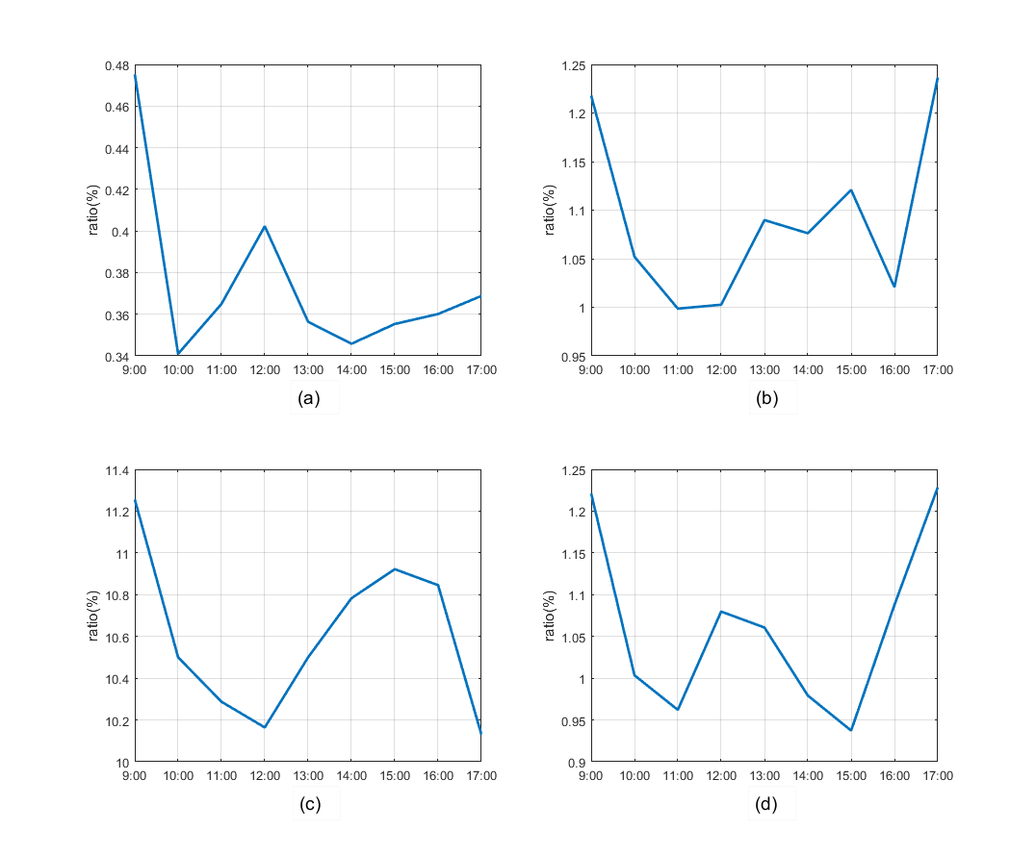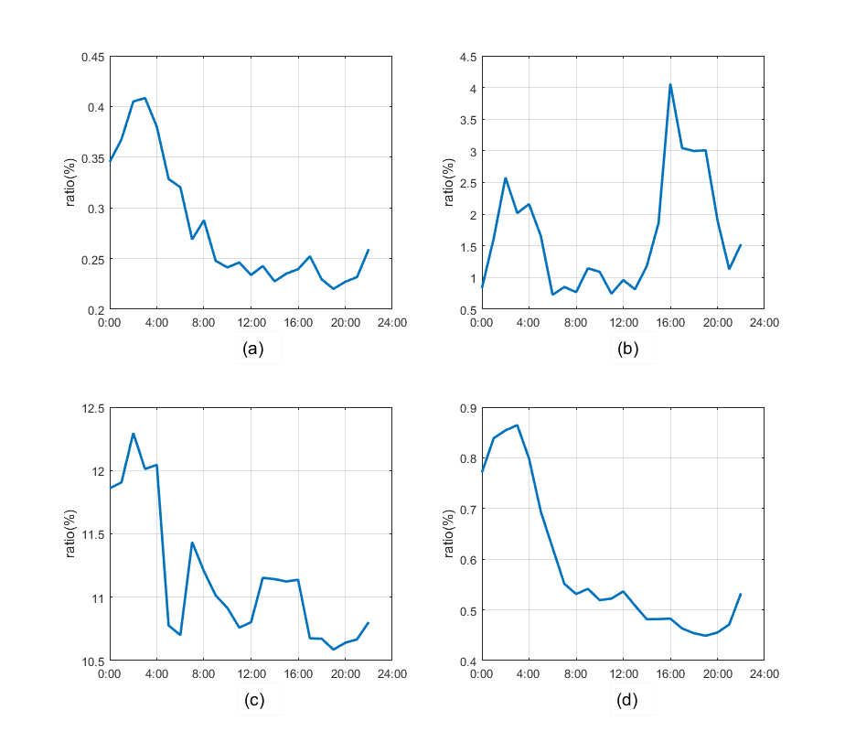Figure 8: The results of experiments using 23 hours of data from Shanxi Province. (a) (b) are the ratio of number of SLDs and DNS records extracted from PRSD and zoom attacks in an interval. (c) (d) are the ratio of number of SLDs and DNS records extracted from DGA in an interval.

Figure 9: The results of experiments using 23 hours of data from Guangdong Province.

# 5 Limitation and discussion

In this paper, we build a malicious traffic extraction system. It can quickly extract the DNS resource records of zoom attacks, random subdomain attacks and DGAs from passive DNS data, rather than just through blacklist or more simple way to filter. Besides, it can greatly reduce the amount of DNS data that is further detected.

In addition, our system also has some limitations. For example, due to the lack of continuous long-term data sources, and the lack of sufficient historical data support, we believe that the construction of data warehouse by using some statistical characteristics of the historical data, to determine the domain name can be clearer. For example, the survival time of DGA domains is usually well below 30 days, and we can build corresponding features to record the number of times over the past few days. Through using this feature, we can significantly identify domain names . The same reason also caused us being unable to explore the timeliness of the model, that is, cannot determine how long the parameters are valid. However, we provide methods for exploring parameters in this paper.

For the extraction of DGA traffic, the recall rate has not reached 100%. Besides, we also have some ideas on how to improve recall rates. The added feature mentioned in the previous paragraph is on the one hand, on the other hand, the DGA is divided into several categories. We need to distinguish whether the DGA is generated using the dictionary or hash, or according to the time pseudo-randomly generated. Meanwhile, we also need to consider the balance time and recall rate, and the closer it is to a complete detection model, the more time it takes, which is what we need to focus on.

In the extraction of DDOS traffic, our method can only select the secondary domain names of the website. When it is related to some of the higher traffic flow of the site, we cannot distinguish between the legitimate traffic and malicious traffic on the same website when we change the domain name into the actual traffic, which may reduce the efficiency of domain name extraction.

# 6 Conclusion

In this paper, we propose a malicious traffic extraction model system. The system refers to the relevant detection system, selects features, and preliminarily filters the domain names and traffic related to some attacks. Compared with the simple pre-processing process, the system can select the malicious traffic to a smaller range, while ensuring the recall rate, but also very fast to achieve their goals, which is to narrow the range for further detection. Our evaluation uses real data from passive DNS data of provincial telecommunication at different times. Amplification attacks and random sub-domain name attacks involved in the domain name recall rate reached 100%, DGA domain name recall rate of 90% or more.

# References

Antonakakis, M., Perdisci, R., Dagon, D., Lee, W., and Feamster, N. (2010). Building a dynamic reputation system for dns. InUsenix Security Symposium, Washington, Dc, Usa, August 11-13, 2010, Proceedings,pages 273–290.

Antonakakis, M., Perdisci, R., Nadji, Y., Vasiloglou, N., Abu-Nimeh, S., Lee, W., and Dagon, D. (2012). From throw-away traffic to bots: Detecting the rise of dga-based malware. In Presented as part of the 21st USENIX Security Symposium (USENIX Security 12), pages 491–506, Bellevue, WA. USENIX.

Bilge, L., Kirda, E., Kruegel, C., and Balduzzi, M. (2011). Exposure: Finding malicious domains using passive dns analysis. InNetwork and Distributed System Security Symposium, NDSS 2011, San Diego, California, Usa, February - February.

Plohmann, D., Yakdan, K., Klatt, M., Bader, J., and Gerhards-Padilla, E. (2016). A comprehensive measurement study of domain generating malware. In 25th USENIX Security Symposium (USENIX Security 16), pages 263–278, Austin, TX. USENIX Association.

Serdar Argic, Shane Atkinson, R. C. Dsbl. <http://www>. dsbl.org/. A blocklist specialized in listing open relays and open proxies.

Perdisci R, Corona I, Giacinto G. Early detection of malicious flux networks via large-scale passive DNS traffic analysis. IEEE Transactions on Dependable and Secure Computing, 2012, 9(5): 714–726

Woodbridge J, Anderson H S, Ahuja A, et al.(2016). Predicting Domain Generation Algorithms with Long Short-Term Memory Networks[J]..

Goldberg, Y., & Levy, O. (2014). Word2vec explained: deriving mikolov et al.'s negative-sampling word-embedding method. Eprint Arxiv.

Thomas Orthbandt. (2015). Nominum. <https://nominum.com/press_item/sharp-rise-in-dns-based-ddos-last-year-signals-larger-more-frequent-attacks-in-2015/>. DNS-based DDoS rise signals more attacks in 2015

Tama, B. A., & Rhee, K. H. (2015). Data mining techniques in DoS/DDoS attack detection: A literature review. International Information Institute (Tokyo). Information, 18(8), 3739.

Karnwal, T., Sivakumar, T., & Aghila, G. (2013). A comber approach to protect cloud computing against xml ddos and http ddos attack, 182, 1-5.

Wang, B., Zheng, Y., Lou, W., & Hou, Y. T. (2015). Ddos attack protection in the era of cloud computing and software-defined networking. Computer Networks, 81(C), 308-319.

Eduard Kovacs. (2014). Large DNS Text Records Used to Amplify DDoS Attacks: Akamai. <http://www.securityweek.com/large-dns-text-records-used-amplify-ddos-attacks-akamai>

C. Liu. A new kind of ddos threat: The â ˘ AIJnonsense nameâ ˘ IA˙ attack. Network World, 2015. [Online; posted 27-January-2015]

VeriSign, Verisign distributed denial of service trends report q4 2015. https://www.verisign.com/assets/report-ddos-trends-Q42015.pdf, 2015.

Rizzo, G., Van Erp, M., Plu, J., & Troncy, R. (2016). Making sense of microposts (#Microposts2016) named entity recognition and linking (NEEL) challenge. CEUR Workshop Proceedings, 1691, 50–59. <https://doi.org/10.1145/1235>

Andrew. (2015). <https://secure64.com/defenses-pseudo-random-subdomain-attacks-prsd/>. MORE DEFENSES AGAINST PSEUDO RANDOM SUBDOMAIN ATTACKS (PRSD)

S. Stover, D. Dittrich, J. Hernandez, and S. Diet- rich. Analysis of the storm and nugache trojans: P2P is here. In USENIX ;login:, vol. 32, no. 6, December 2007.

Wikipedia. The storm botnet. http://en. wikipedia.org/wiki/Storm_botnet, 2010.

J.Williams. What we know (and learned) from the waledac takedown. http://tinyurl.com/ 7apnn9b, 2010.

abuse.ch. ZeuS Gets More Sophisticated Using P2P Techniques. http://www.abuse.ch/ ?p=3499, 2011.

Rahbarinia, B. (2016). Segugio:Efficient and Accurate Behavior-Based Tracking of Malware-Control Domains in Large ISP Networks, 19(2). https://doi.org/10.1145/2960409

YADAV, S., REDDY, A. K. K., REDDY, A. N., AND RANJAN, S. Detecting Algorithmically Generated Malicious Domain Names. In Proceedings of the 10th ACM SIGCOMM Conference on Internet Measurement (2010), IMC ’10.